Template for abstracts preparation

P.B. First¹, K.B. The second^{1,2}, I.D. Third²

¹ Name of institution and postal address

²If the institution name and address do not fit in one line,
the address is completely transferred to another line

The thesis of the report should be prepared by «camera-ready».. To prepare abstracts, you can use this template or make the settings shown below. The volume of abstracts accepted for publication should be 1 page, including images and a list of literature, if any. Materials are represented in the Word editor, a file in the format: *.doc or *.docx.

You must set the following "Page Setup": A4 size, all fields 2 cm
The entire text is printed in Times New Roman with a single line spacing.
The title of the article is the size 14, the alignment is centered, the interval from the bottom is 6 pt.
Authors - size 10, initials before the surname, alignment - in the center, the interval from the bottom - 6 points.
Organization - name and address, size 9, alignment - centered, italic (inclined)

Before the main text, insert an empty line.
The main text is placed in 2 columns with a space of 1 cm. Size 10, straight text, aligned to the width, with automatic transfer turned on. The indent of the first line is 0.5 cm.
Formulas are printed in basic type and size (10 pt). If placed on a separate line, they are centered, without a red line. The numbering of the formulas in parentheses is pressed to the right edge of the column.
Please, write physical units and their abbreviation in accordance with international standards in direct type (Electronvolt - eV, Millielectronvolt - meV, kiloelectronvolt – keV, Megaelectronvolt - MeV, kilohertz - kHz, Megahertz - MHz, gigahertz - GHz, terahertz - THz. etc.)
The preferred width of the images is in the width of the column (8 cm). Before the image and after the signature, add an empty line.

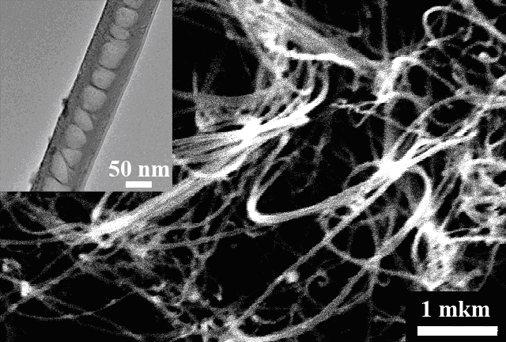

Fig. 1. Figure captions - size 9, in a direct font, the words Fig. 1. should be highlighted in bold. If the signature is short, it is centered; If long - it is allocated on width without a red line.

Materials can be presented in both Russian and English.
The list of literature is compiled in accordance with international standards, font size 9, author names in italics (see sample). References to the literature in the text are typed in square brackets [2]. Before the list of literature-indent 6 pt.
1. K.T. Ramakrishna Reddy, N. Koteswara Reddy, R.W. Miles. Solar Energy Materials & Solar Cells, (2006), 90, 3041–3046.
2. S.A. Bashkirov, V.F. Gremenok, V.A. Ivanov. FTS, 2011, 45, 765-769.
3. S.A. Bashkirov, V.V. Lazenka, V.F. Gremenok, and K. Bente. J. Adv. Microsc. Res., 2011, 6, 153-158.

